Title
Name Surname ¹*, Name Surname ², and Name Surname ²
¹affilated university, Country
² Second affiliation, Country
* Corresponding author: author@university.xx;
This electronic document is a “live” template and is used to format the paper and style the text. The template saved as “MS Word Abstract. An abstract is a summary of the paper (preferably written in one paragraph), where the relevance, purpose and objectives of the paper, the method (s) and results used in the research will be clearly and succinctly stated. The number of words in the abstract should not exceed 250. References and conclusion in the abstract are not recommended. Authors must prepare their papers by strictly adhering to this template.

Key Words: Keywords should reflect the main content, and the principal concepts presented in the paper. Authors are requested to provide no more than five (5) keywords.

- Introduction.
Document”, provides authors with most of the formatting specifications needed for preparing electronic versions of their papers. The features of various components of the paper (title, abstract, keywords, text, heads, etc.) are already defined on the style sheet with the appropriate name supplied.
The title of the paper should be short and informative, should correspond to the results presented in the paper. Preferably, the title should not contain more than 10 words. It is not advisable to use your own names, trademarks or brand names in the title, as well as to use evaluative terminology (eg: accurate; important; good, etc.)
The author is authorized to determine the structure of the presentation of the work, i.e in the text of the work “1. Introduce other parts after "Introduction", for example: "2. Literature Review"; „3. .......... “; „4. Results”, „5. Conclusion” and others (at the discretion of the author). Authors must keep their camera-ready paper in the A4 paper size, Times New Roman font is strictly required, all margins, line spaces and text fonts shall be according to this template, and page numbers should not be added.
- Sumbission
Submission of MS Word document files, not PDFs, are required to typeset a paper for final publication. Authors are fully responsible for the content/originality of the paper and for the English language quality of the text. Therefore, it is necessary for the complete text of papers to be thoroughly checked or proof-read by an English language expert.
Authors have to submit their papers electronically on following email gmsjournal@bsma,edu.ge. All correspondence, including notification on the submission decision and request for revision, is sent by the e-mail.

- Paper Text Formatting
Papers have to be written in good English using either UK or US spelling. The minimum length of the paper should not exceed 10 pages including illustrations, tables and references. The file size should not exceed 10 MB.
All papers will undergo peer review and must meet the journal’s standards for technical quality and written English. In addition, submission will be checked using Turnitin for originality and similarity, as well as for the presence of AI-generated content.
  - Illustrations
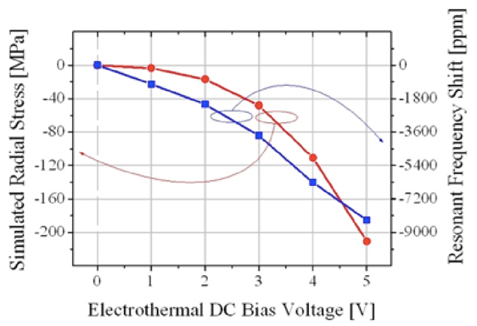
Electronic versions of the published Proceedings will retain color. It is the author's responsibility to ensure that all colored illustrations (figures, photographs, graphs, images) are readable. Illustrations should contain only English labels and be prepared in the final published size, not oversized or undersized. Illustrations have to be embedded in the text (not supplied separately) and placed next to the relevant text on paper. Each illustration has to have a caption (Figure 1) and title.

Figure 1. An example of a figure.
  - Tables
Tables have to be submitted as editable text and not as images. Tables have to be embedded into the text (not supplied separately) and placed next to the relevant text in the paper. Tables have to be numbered consecutively in accordance with their appearance in the text. Each table should have a caption (Table 1) and Title.

Table 1. An example of a table.
An example of a column heading | Column A | Column B
First entry | 1 | 2
Second entry | 3 | 4
Third entry | 5 | 6

3.3. Mathematical Formulae
Formulae and equations must be prepared in an editable format using MS Equation Editor 3.0. They should be displayed separately from the main text, centered, and numbered sequentially with Arabic numerals, aligned to the right margin. This is an example of an equation:
$$A=πr^{2}$$ | (1)
$${\left(x+a\right)}^{n}=\sum_{k=0}^{n}{\left({n \atop k}\right)x^{k}a^{n-k}}$$ | (2)
the text following an equation has to be a new paragraph. Equations have to be punctuated as regular text.

3.4. Footnotes and Acronyms
Footnotes should be avoided. Acronyms have to be spelled out on their first use, followed by the acronym in parentheses.

Acknowledgements
If a funding has been provided for the research, please include brief information on the program or type of grants and awards.
References
Reference list style has to be the APA7 style. Some basic rules of APA7 citations: In-text citations include the last name of the author followed by a comma and the publication year enclosed in parentheses, (e.g., (Jones, 1998, p. 5)), which refer to the full citation listed in the reference list at the end of the paper. The reference list is organized alphabetically. In the in-text citation. If you are quoting directly, the page number should be included, if there is a page number: (Louie, 2023, p. 117). If you are paraphrasing, the page number is not required. It is not necessary to make in-text citation in abstract. If you refer to the author's name in a sentence you do not have to include the name again as part of your in-text citation. Instead include the date after the name and the page number (if there is one) at the end of the quotation or paraphrased section. For example: As Srinivasan and Collard (2023) point out, conservation programs have actively caused harm to one form of non-human wildlife in order to protect some other aspect of nature or biodiversity (p. 289-290).
When citing multiple works at once, place them in parentheses, separated by semicolons and listed in alphabetical order by the author's last name. Example: (Coates, 2005; McMinn, 2003; Ng et al., 2007).
Foreign sources must be indicated in the original language.

